**RTL Functionality document**

* STA to AP mode switching steps:

Power on the custom board. By default, it is on STA mode. Need to switch Ap mode to connect your WIFI network. For connect a network follow below steps.

1. Click on the button to shift Ap mode like below shown image.

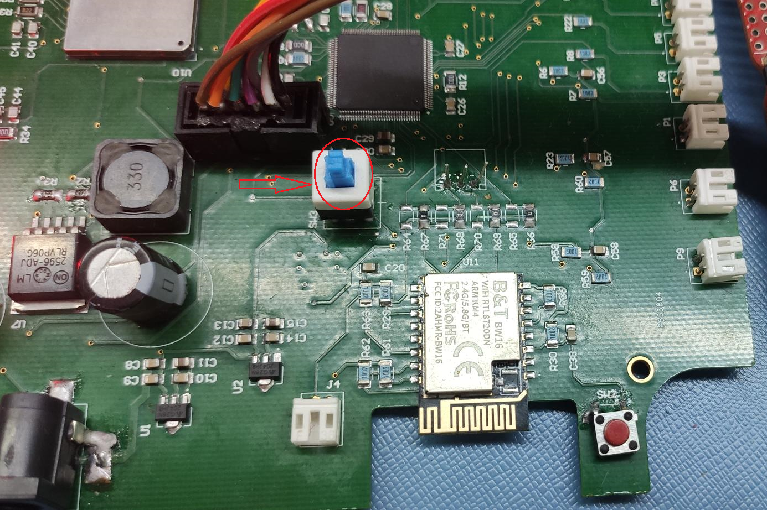

1. Enable the WIFI on mobile phone or pc. Then it will show the RTL SSID “IOT_”, click on it to connect the device.

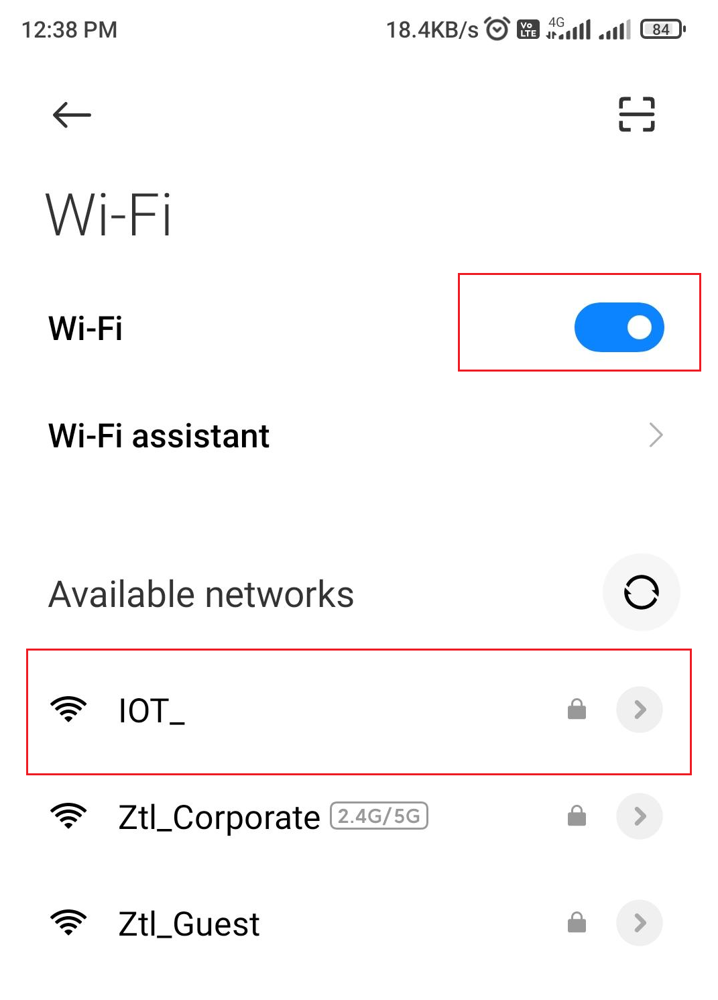

1. To connect the RTL device, enter the below provided SSID and PASSWORD

SSID: IOT_

PASSWORD: iot@12345678

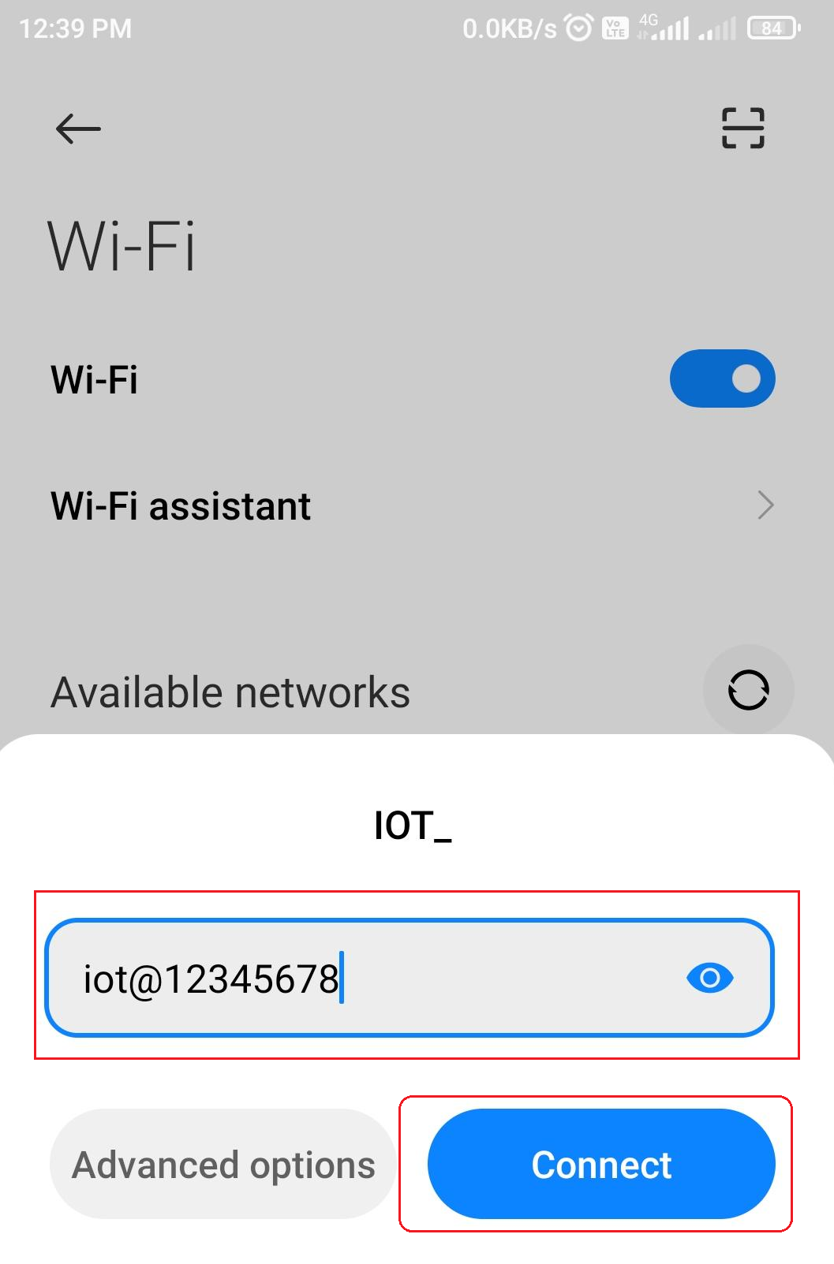

1. After connect the network it is showing like below image.

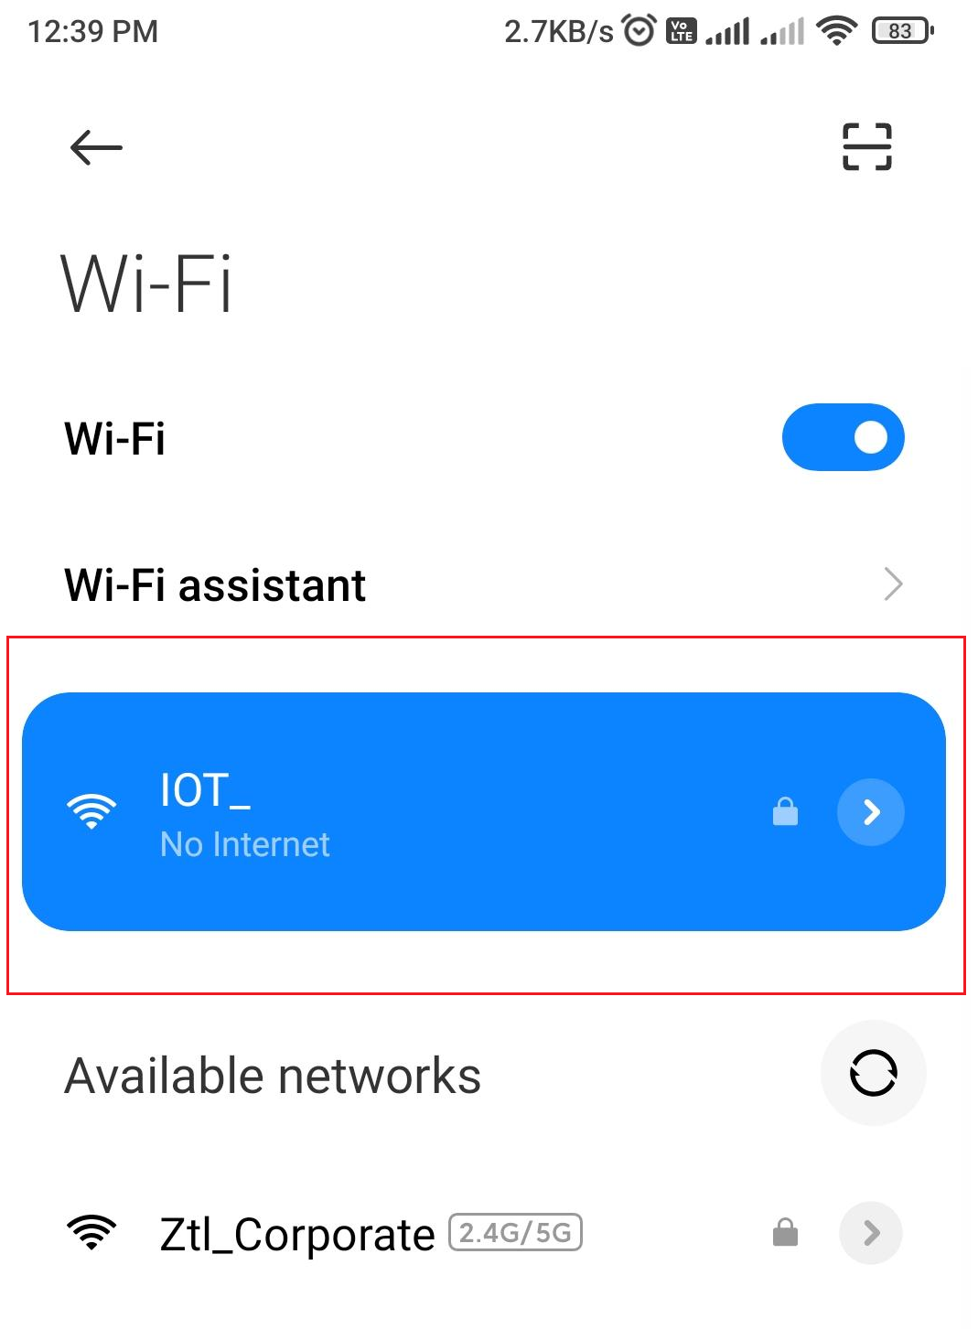

1. After connecting the network open google Crome and in the URL enter the IP address 192.168.1.80 then click on enter. It will open the web page. I.e. PARAGON IOT Input Form

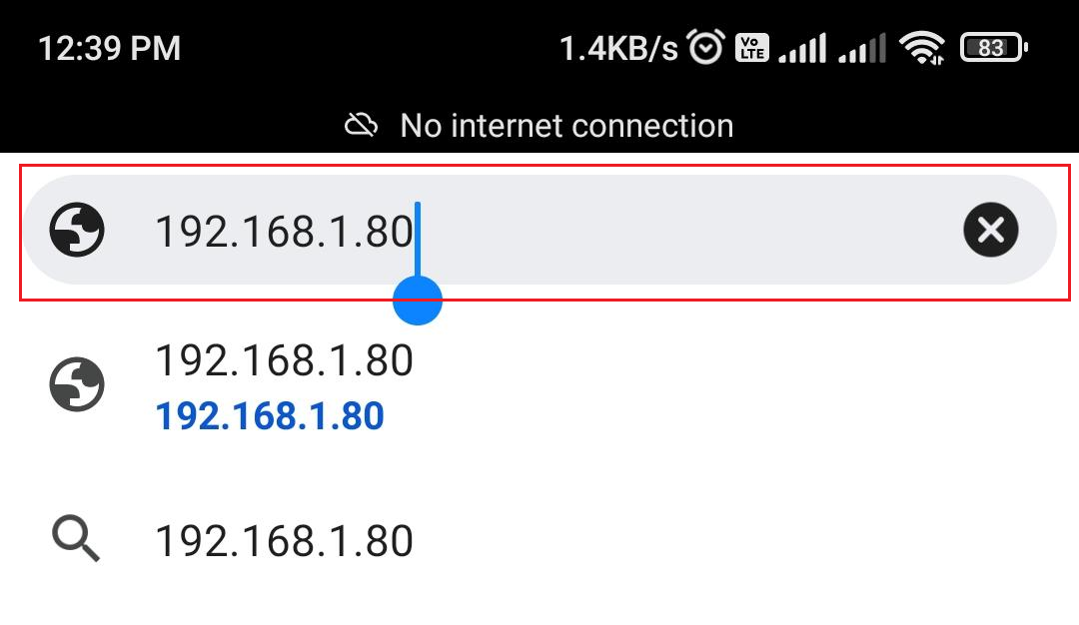

1. In the PARAGON IOT Input Form, you need to provide your available WIFI network username and password, then click on login button. As shown in below image.

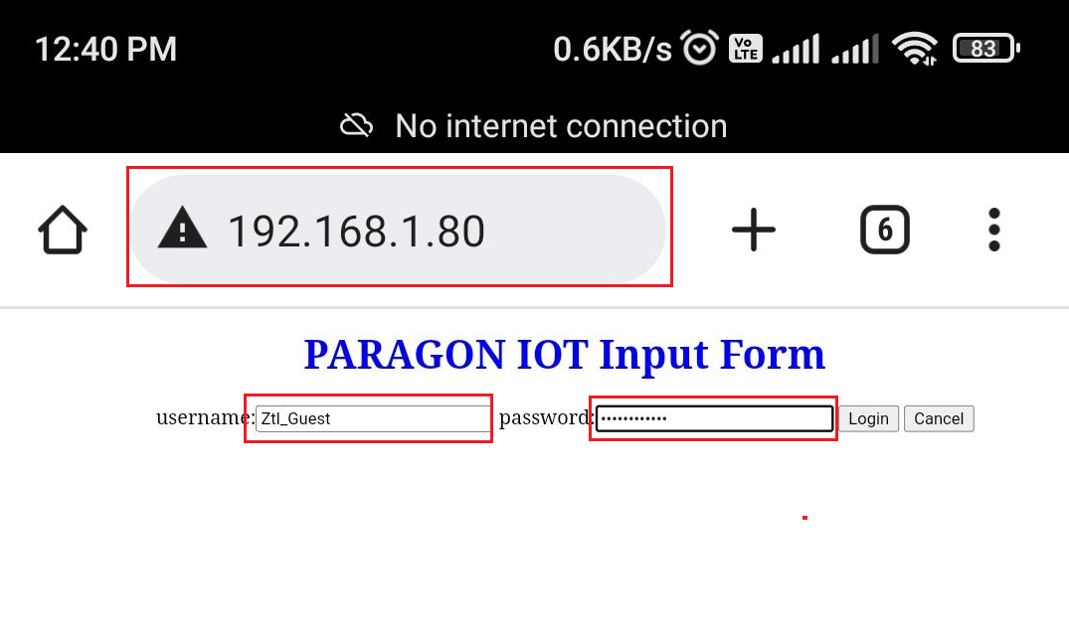

1. These credentials saved in RTL flash storage.
2. Again, we need to switch the mode AP to STA for publishing the data.

* AP to STA mode switching steps:

1. Release the button to enter the STA mode (in STA mode button look like Hight). As shown in below image.

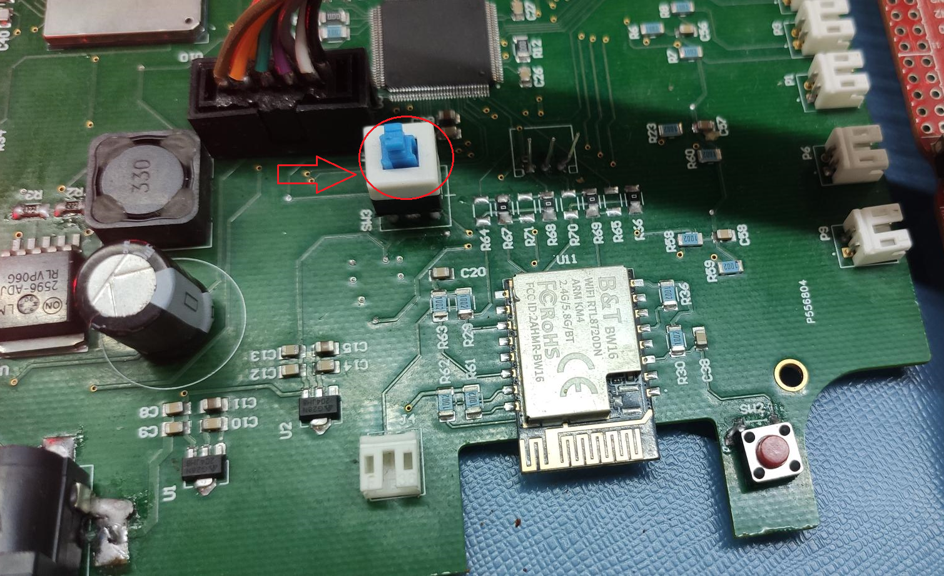

1. Then click on the RTL reset button. Same as shown in below image.

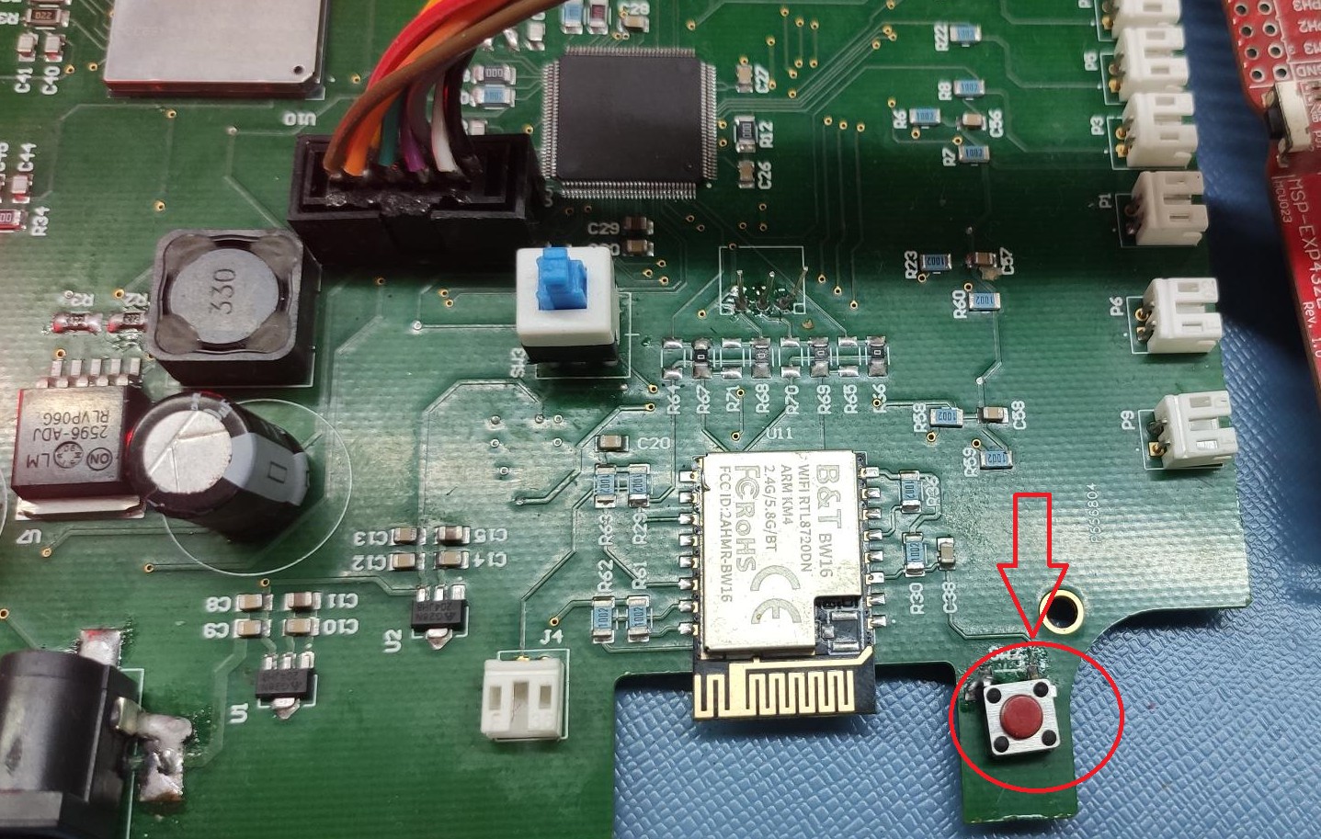

1. In the RTL using of the WIFI publishing the data.

* MSP WIFI mode switching steps:

1. For choosing the WIFI MODE press the button as shown in below image.

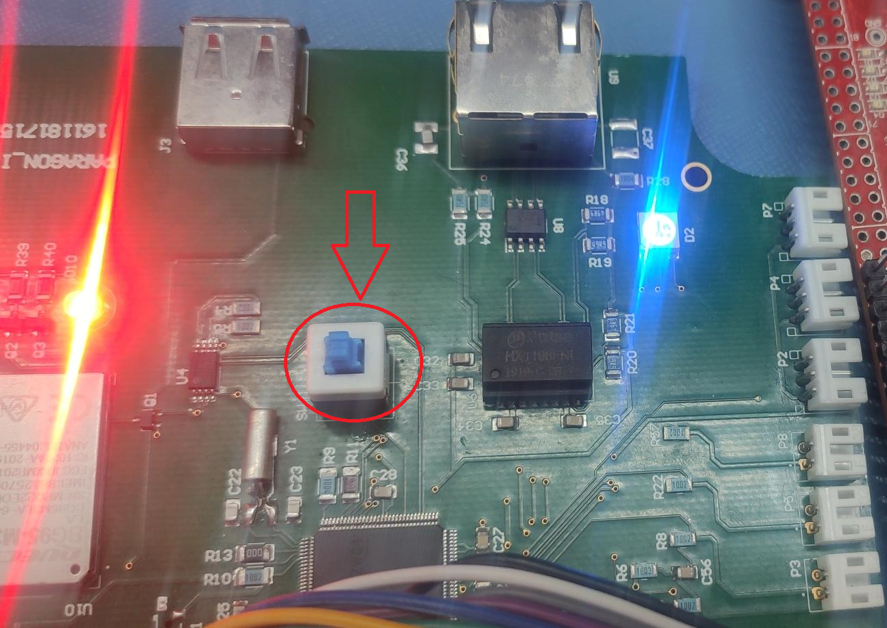

1. For indication of the WIFI mode the RGB led should be “BLUE “color.

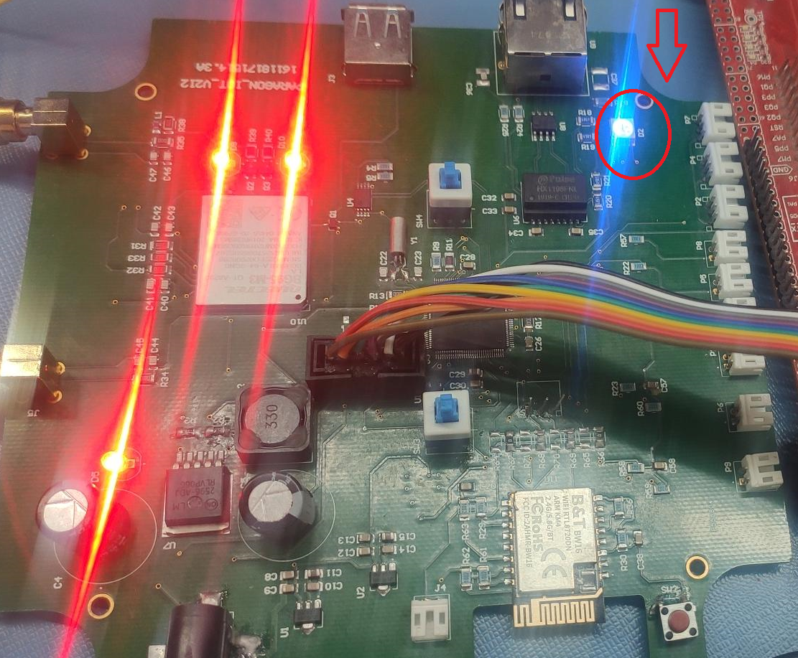

The final image looks like above image for publishing the data in Wi-Fi mode.

* **Result verification in MKS Vision device dashboard**

1. For verifying the results click on the below link

**http://paragon.mksvision.com/mksvision**

1. After open this page enter the credentials like below:

Username: admin

Password: admin@123

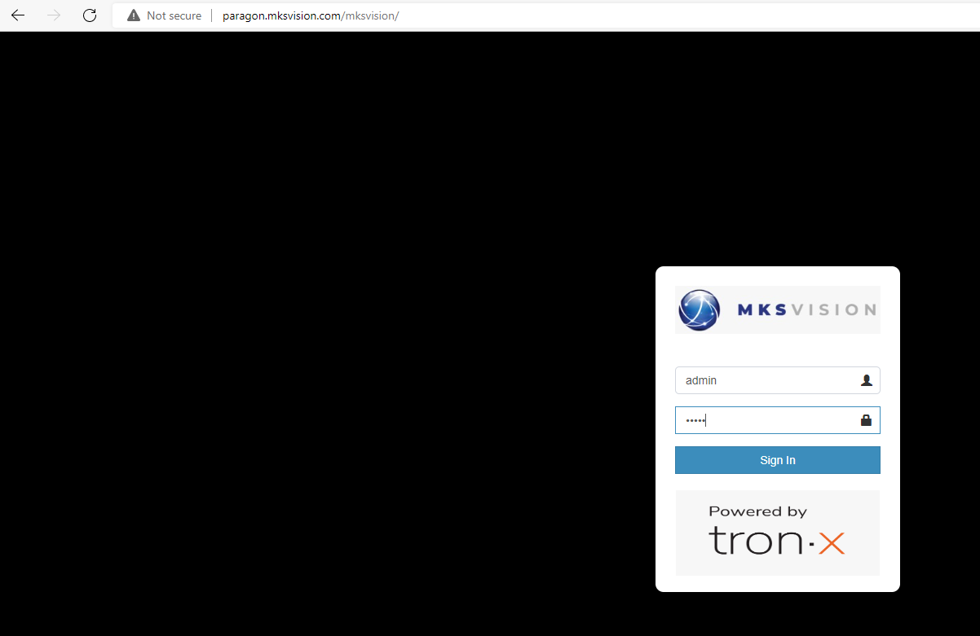

1. After login the webpage click on the Device dashboard option and then select the device Id as shown in below image.

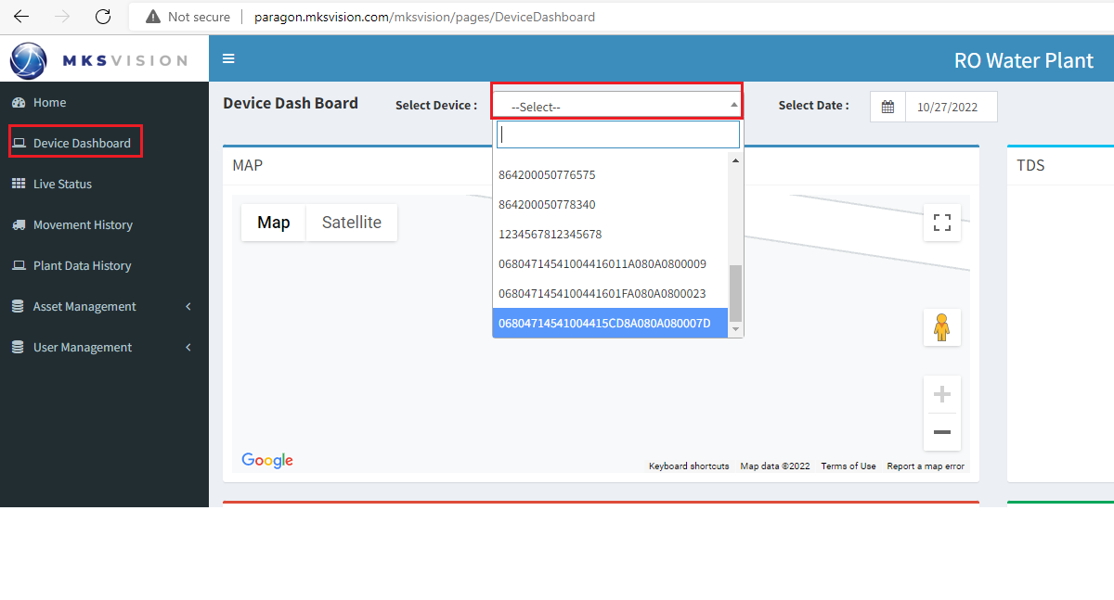

1. In this dashboard will show the result of that bord readings like shown in below.

